Firewall Fundamentals - Lab Report

Date: 05/06/2026
Difficulty: Easy
Category: Security Solutions
Platform: TryHackMe

Overview

This lab looks at what firewalls are and the different types of firewalls to keep networks and devices secure from malicious traffic. It looks at Linux firewalls such as Netfilter and UFW and also Windows Defender Firewall with a practical example of denying HTTP/HTTPS traffic from the host and what details you need to run it.

2. Toolset Used

Tool | Purpose / Function
Windows Defender Firewall | Windows built-in firewall that allows you to configure inbound/outbound/ rules on your home network or public/untrusted networks

3. What I did

A firewall is used to inspect a network or digital devices incoming and outgoing traffic by assigning rules to check against this traffic. The firewall will then allow or deny the traffic based on if it passes the set rules or not. There are several types of firewalls such as:

- Stateless – this operates on layer 3 + 4 of the OSI model and works by filtering the data based on predetermined rules without taking note of the state of the previous connection which means it matches every packet with the rules regardless of whether it is part of a legitimate connection or not. This means that it can process the packets quickly but they can’t apply complex policies to the data based on its previous connections. For example, if it has multiple dropped packets from an IP then it should drop all future packets from that IP but since it is stateless, this does not happen.
- Stateful – this type filters packets but it also keeps track of previous connections and stores them in a state table which adds another layer of security by inspecting the packets based on their history. This firewall also operates on layers 3 + 4 of the OSI model.
- Proxy – they operate between the private network and the internet and on layer 7 of the OSI model. They inspect the content within the packets which other firewalls cannot do. Content filtering is used to allow/deny incoming and outgoing traffic based on their content.
- Next-Generation (NGFW) – the most advanced type of firewall and operates from layer 3 to layer 7 of the OSI model. It offers deep packet inspection and other features that enhance the security of incoming and outgoing traffic. It has a built-in IDS that blocks malicious activity in real time. It uses heuristic analysis to analyse patterns of attacks and blocks them before reaching the network. It also has SSL/TLS decryption to decrypt packets and inspect them.

Firewalls come with built-in rules, but security analysts can add their own customised rules for their network. Firewall rules have components such as source address, destination address, port, protocol, action (allow/deny/forward) and direction (incoming/outgoing/forwarding). Allow actions accept the traffic, deny actions block the traffic and forward actions redirects traffic to a different part of the network. Inbound rules are for traffic entering the network, outbound rules are for traffic leaving the network and forward rules are for forwarding traffic inside the network.

Windows Defender is a built-in firewall created by Microsoft in the Windows OS. To find and open the firewall, type Windows Defender Firewall into the search bar. There are 2 network profiles – Private networks and guest/public networks. Private networks are the rules for when connected to your home network whereas guest/public networks are the rules for when connected to a public or untrusted network like shops or restaurants.

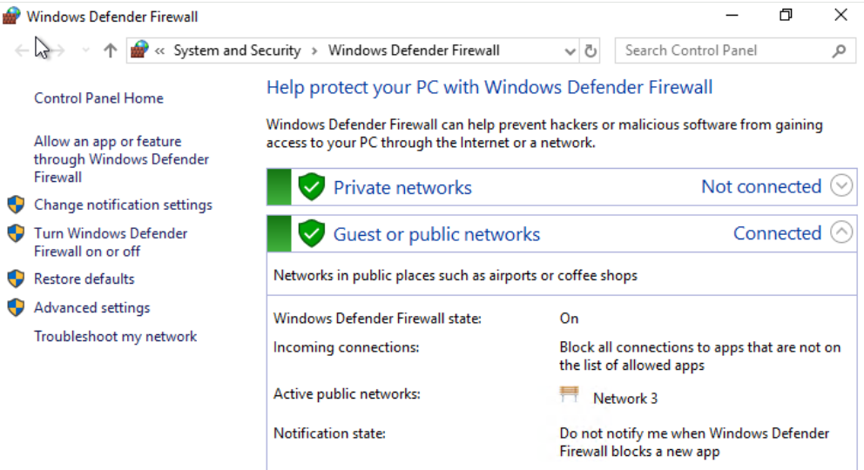

The settings down the left of the image above let you turn the firewall on/off, restore defaults, select apps to use the firewall on and more. To create a custom rule to block all outgoing traffic on ports 80 and 443, click advanced settings > outbound rules > new rule.

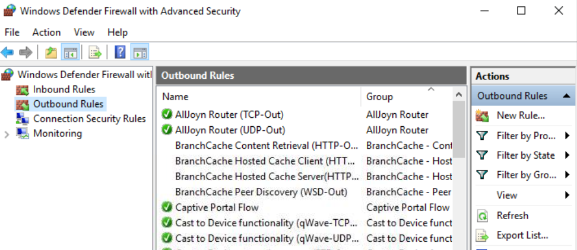

From here, set the protocol to TCP and the remote port to 80 and 443.

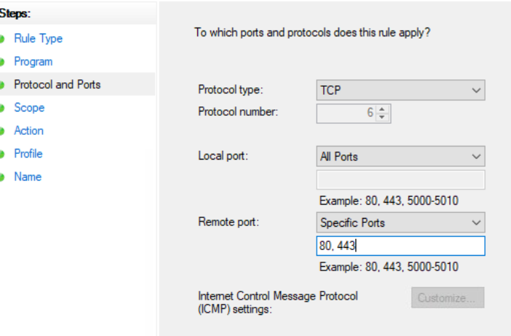

Next, select block the connection to deny the traffic

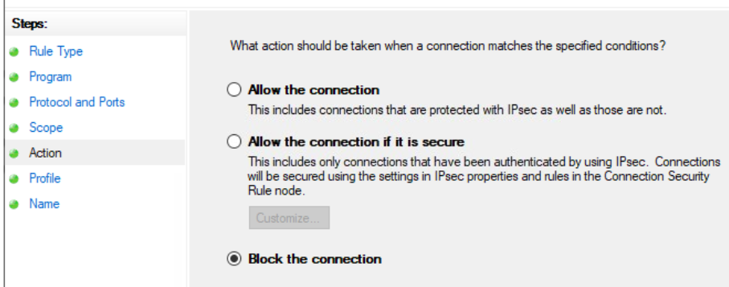

When I try to view a webpage on HTTP, it doesn’t show anything and is blocked.
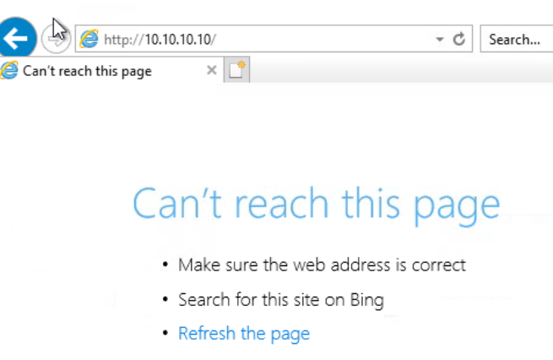

Linux also offers a built-in firewall but there are a few options:

- Netfilter – the framework inside the Linux OS with core firewall features such as packet filtering, NAT and connecton tracking. This framework is the foundation for various firewall utilities in Linux such as iptables, nftables and firewalld. Iptables is the most used as it controls network traffic, nftables is the successor to iptables as it has enhanced packet filtering and NAT. Firewalld has predefined rule sets but works differently to the others as it has pre-built network zone configurations.
- UFW (uncomplicated firewall) – uses an easier interface and beginner friendly. You can check the status using “ufw status” command, “ufw enable” enables it, “ufw default deny outgoing” denies outgoing traffic from your machine as a default policy.

4. What I’ve learned

- Types of firewalls and how they differ
- Windows Defender
- Linux firewall solutions

